 | intention |  |  | Respons ibility |  |  |  | AR→ CM → RCI (Supported)
10. | Less is more! A pathway to consumer 's transcend ence | Trang Thi- Thuy Duong, Liem Viet Ngo,  Jiraporn Surachartk umtonkun  , | Journal of Retailing and Consume r Services | Minimali sm | Perceived transcende nce | Moral Identity | Quantitative | Model 1:  Minimalism → perceived transcendence (β = 0.65, p < 0.001)  Model 2:  Moral identity x Minimalism → Perceived transcendence (β = 0.16, p < 0.001) (Supported)
 |  | Mai Dong Tran, |  |  |  |  |  | Minimalism → moral identity (β = 0.47, p < 0.001) (Supported)
 |  | Gavin Northey |  |  |  |  |  | Moral identity → perceived transcendence (β = 0.34, p <  0.001) (Supported)
 |  |  |  |  |  |  |  | Minimalism → perceived transcendence (β = 0.49, p <

 |  |  |  |  |  |  |  | 0.001)
11. | Understa nding the Predictor s of Sustainab le Food Consump tion Behavior: A  Pathway to Achieving Sustainab le Develop ment Goals | Vivek Thakur, Shampy Kamboj, Mohd Adil | Sustaina ble Develop ment | Consequ ence percepti on | Acquisition  , Usage, Disposal | Responsibil ity attribution, Consumer attitude, Individual norms, Consumer minimalis m, Sustainable intention. | Quantitative | CP → RA (β = 0.526, p < 0.001)  CP → IN (β = 0.601, p < 0.001)  (Supported)  RA→ IN (β = 0.187, p < 0.001)  (Supported)  CP → CA(β = 0.290, p < 0.001)  (Supported)  IN → CA (β = 0.287, p < 0.001)  (Supported)  IN → CM (β = 0.412, p < 0.001)  (Supported)  CA → SI (β = 0.148, p < 0.05)  (Supported)  CM → SI (β = 0.424, p < 0.001)  (Supported)  SI → AC (β = 0.595, p < 0.001)

(Supported)
SI → US (β = 0.115, p < 0.05)
(Supported)
SI → DS (β = 0.489, p < 0.001)
(Supported)

Proposed Hypotheses and Research Model
    - The relationship between Simple Aesthetics and Minimalism
According to Wilson, and Bellezza (2024), minimalist aesthetics are defined by minimalistic areas, items, and collections, often characterized by simple design, clean lines, minimal decoration, and a monochromatic color palette. This approach encourages individuals to eliminate everything superfluous, retaining only what is truly essential (Kamal & Nasir, 2022). In fashion, this translates to decluttering one's wardrobe, removing clothes that no longer fit, and, more importantly, resisting the desire to purchase trendy but non-essential items. This act of selecting and refining a wardrobe brings a efficiency and elegance through the deliberate reduction of components, ultimately being minimalist (Sandlin & Wallin, 2022).
Previous studies have suggested that simple aesthetics are the foundation of minimalism. The research by Martin-Woodhead and Waight (2023) indicated that Minimalism is built upon a foundation of minimalist aesthetic distinguished by simplicity, moderation, and the intentional removal of non-essential elements. Similarly, Wilson and Bellezza (2022) and Laaksonen (2024) also concluded that Minimalism is conceptualized as a three-dimensional reflective-formative construct: intentionally selected consumption, the number of possessions, and simple aesthetics. Like the studies above Jain, Joy, and Sharma (2024) stated that Minimalism here is defined as a concept that includes the removal of non-essentials, intentional consumption, simple aesthetics, financial freedom, and a sustainable lifestyle. In summary, a key commonality of these studies is that they view simple aesthetics as an attribute, a characteristic, or a preference of someone who is already a minimalist. These studies describe a static state: if you are a minimalist, you tend to prefer simple aesthetics. Differing from these studies, the pioneering research by Jain, Joy, and Sharma (2024) demonstrated that simple aesthetics have a positive impact on minimalism, with a Beta coefficient of 0.553. Recognizing this

distinction, our subsequent research direction will be to replicate and evaluate this relationship in a new environment and context: Ho Chi Minh City. Based on these arguments, the authors propose the following hypothesis:
H1: Simple aesthetics have a positive impact on minimalism.

The relationship between Greenwashing Perception and Minimalism
The phenomenon of greenwashing has become a prominent issue in the fashion industry, with many brands using "green" marketing strategies without concrete evidence. According to Adamkiewicz, Kochanska, Adamkiewicz, and Łukasik (2022), greenwashing not only distorts consumer perception but also hinders the development of sustainable fashion. The ambiguity and exaggeration in sustainability claims make consumers increasingly skeptical, leading to a decline in brand trust (Alizadeh, Liscio, & Sospiro, 2024). For example, H&M once labeled a product line "Conscious" without demonstrating specific environmental benefits, causing widespread controversy and raising concerns about transparency in green communication (Kaner, 2021). According to Paudel (2024), both Generation X and Y exhibit higher levels of skepticism as their perception of greenwashing increases, resulting in a reduced purchase intention for sustainable fashion.
From the perspective of Brehm's (1966) Psychological Reactance Theory (PRT), individuals have a need to maintain their cognitive and behavioral freedom. When they feel manipulated by dishonest communication campaigns, they experience reactance, manifested through avoidance, opposition, or seeking alternatives to restore a sense of control (Brehm & Brehm, 1981). In this context, minimalism can be seen as a form of resistant consumer behavior.
According to Wilson and Bellezza (2022), minimalism is a life philosophy oriented towards simplicity, valuing spiritual well-being, freedom, and authenticity, while also expressing an attitude of resistance against materialism and conspicuous consumption. When consumers perceive greenwashing, they may feel their ethical values are being

exploited for commercial purposes, leading to psychological reactance. Consequently, they reject "fake green" products and shift to a consumption style that expresses autonomy such as minimalist fashion, which emphasizes genuine sustainability, individuality, and control over choices. Based on these arguments, the authors propose the following hypothesis:
H2: Greenwashing Perception has a positive impact on the tendency to pursue Minimalism.

The relationship between Sustainable Label Awareness and Minimalism
Sustainable labels often serve as an indicator of quality. For example, a textile product with GOTS (Global Organic Textile Standard) certification not only guarantees the origin of the fibers but also a strict production process, which often corresponds to higher durability. Eco-labels are therefore considered an effective tool to help consumers identify environmentally friendly products and support them in making sustainable purchasing decisions (Jimenez-Fernandez, Aramendía-Muneta, & Alzate, 2023). When consumers have a high awareness of sustainable labels, they not only increase their behavioral intention towards green products (Bezençon & Etemad-Sajadi, 2015) but also tend to adjust their lifestyle and consumption behavior towards being more selective, focusing on use-value, and reducing excess. Therefore, with awareness of these labels, minimalist consumers can more easily identify and choose products that align with the "less is more" philosophy. The study by Sher Singh Yadav and Sanjay Kumar Kar (2025) also shows that awareness of sustainable labels positively impacts minimalism. However, this relationship has not been extensively explored in previous research. Therefore, the research team will include it in the model to enhance novelty when testing it in the context of Ho Chi Minh City. These are the core characteristics of minimalism: valuing simplicity, limiting overconsumption, and moving towards sustainable, long-lasting choices. Based on this, the research team proposes the hypothesis:
H3: Sustainable Label Awareness has a positive impact on Minimalism.

The relationship between Environmental Concern and Minimalism
Environmental concern is understood as an individual's level of awareness, anxiety, and willingness to act to protect the environment (Dunlap & Jones, 2002). Some studies suggest that minimalists often have environmental concerns (Herziger, Berkessel, & Steinnes, 2020; Martin-Woodhead, 2021). The Theory of Planned Behavior (Ajzen, 1991) states that a positive attitude towards the environment, formed from personal awareness and values, will result in a desire to perform environmentally friendly behaviors. Furthermore, The Norm-Activation Theory (Schwartz, 1977) states that individuals with high environmental concern often develop a sense of moral responsibility towards nature, which in turn motivates them to choose a simple lifestyle and controlled consumption (Blackburn, Leviston, & Walker, 2025).
Recent studies also provide empirical evidence supporting this relationship. Blackburn, Leviston and Walker (2025) showed that environmental concern is the key driver for low - consumption lifestyles such as minimalism and voluntary simplicity. Similarly, Jain, Joy and Sharma (2024) affirmed that people with high ecological consciousness are more likely to adopt a minimalist lifestyle because they see it as a way to lessen their adverse environmental effects. The Şener, Bişkin, and Dündar (2022) found that environmental issuses were found to have a stronger impact on purchase intention, despite showing only a slight positive impact on customers’ attitudes toward sustainable fashion consumption. Balderjahn, Seegebarth, and Lee (2020) also found that sustainability awareness significantly influences the trend of consumption reduction, emphasizing the role of ecological values in shaping lifestyle choices.
From these theoretical foundations and empirical evidence, it can be seen that environmental concern not only shapes a positive attitude towards environmental protection behaviors but also motivates individuals to adjust their fashion consumption habits, moving towards a more minimalist and sustainable daily life. Based on these arguments, the authors propose the hypothesis:

H4: Environmental concern has a positive impact on the tendency to pursue Minimalism.

The relationship between Price Perception and Minimalism
Price is understood as a unit of value that consumers exchange for the right to own and use a product or service to benefit from it. Price has long been considered a crucial signal in the consumer decision-making process, not only reflecting affordability but also shaping how consumers evaluate product value (Zeithaml, 1988). According to Kotler and Armstrong (2018), price perception includes two aspects: price attractiveness (the consumer's opinion of the offered price) and price fairness (the degree to which the cost appropriately represents the advantages that the good or service offers). According to Perceived Value Theory, purchase decisions are influenced not just by the absolute price but by the comparison between perceived value and the cost incurred. When consumers have a high price perception, they tend to consider the total lifecycle cost, long-term use- value, and financial efficiency rather than just the initial purchase price. This leads to a shift from short-term consumption to more strategic and sustainable consumption behaviors.
In this context, minimalism has emerged as a consumption trend that emphasizes necessity, quality, and durability, helping consumers reduce excess spending and optimize use-value. Recent studies show that a minimalist lifestyle not only brings financial benefits but also enhances consumers' happiness and mental well-being (Blackburn, Leviston, & Walker, 2025). Particularly in the fashion industry, the "buy-use-dispose" consumption model has created a short-term consumption loop, pushing consumers into a state of repeated financial drain due to constant product replacement. Although these products have a low initial price, their actual total cost of ownership is much higher than that of high-quality, long-lifespan products. When consumers become aware of this disparity, their approach to consumption behavior changes from focusing on short-term benefits to emphasizing long-term financial efficiency. Minimalism in consumption is the trend of

selectively choosing products, prioritizing quality, necessity, and durability, rather than shopping based on quantity or fleeting trends. The minimalist lifestyle emphasizes "less but better" while minimizing waste and optimizing the use-value of products. Based on the theoretical and empirical arguments above, this study proposes:
H5: Price perception has a positive impact on the tendency to pursue Minimalism.

The relationship between Environmental Concern and Sustainable Fashion Consumption Intention
Environmental concern can be seen as an attitude or value orientation that reflects consumers' beliefs about the relationship between humans and nature, particularly regarding the impact of the fashion industry (Fransson & Garling, 1999). Based on Schwartz's (2012) value model and the work of Stern and Dietz (1994), this concern can stem from different values such as egoistic, altruistic, and biospheric, thereby influencing attitudes and behaviors related to fashion consumption.
Research has demonstrated that pro-environmental conduct is frequently significantly predicted by environmental concern and sustainable consumption intention, including in the fashion sector (Yue, Li, Liu, Jin, & Bao, 2020). Particularly in the post- COVID-19 context, issues such as pollution from the textile industry and resource waste have become urgent, making consumers more aware of the importance of responsible fashion consumption behavior (Sarmadi, Rahimi, Evensen, & Kazemi Moghaddam, 2021). Consequently, environmental concern has increasingly become a key driver, motivating consumers to seek and choose green, environmentally friendly fashion products, as well as to adjust their shopping behavior to limit negative impacts on nature.
Dunlap and Jones (2002) define environmental concern as the extent to which consumers care about and support initiatives to address environmental issues, demonstrated through behaviors such as purchasing green or sustainable fashion products. Many studies also confirm that it is the important predictor of pro- environmental behavior and sustainable consumption intention (Hartmann & Apaolaza-

Ibáñez, 2012; Yue, Li, Liu, Jin, & Bao, 2020; Rausch & Kopplin, 2021). Specifically, a study by Park & Lin (2020) showed that environmental concern positively influences the intention to purchase recycled and upcycled fashion products. Based on the above results, it is suggested that people with a high level of environmental concern will have a stronger intention for sustainable fashion consumption. Therefore, the research team proposes the following hypothesis:
H6: Environmental concern has a positive impact on consumers' sustainable fashion consumption intention.

The relationship between Price Perception and Sustainable Fashion Consumption Intention
According to Prihatini and Gumilang (2021), price is considered a measure of the value that consumers must give up to own and use a fashion product, thereby receiving desired benefits such as style, self-expression, and quality. In the fashion industry, researchers acknowledge that price plays a pivotal role in determining purchasing behavior (Kalyanaram, Saini, Mony & Jayasankaran, 2022), especially when comparing fast fashion with sustainable fashion. Price is often regarded as one of the most critical factors in fashion marketing and brand management (Unal & Tascioglu, 2022). Consumers always compare the price of a fashion item with other products before making a purchase decision (Ghaffar & Islam, 2023). According to Hride et al. (2021), if customers perceive that the quality, durability, and design offered by a fashion product are high, they will deem the price reasonable and be willing to pay it.
People with ecological concerns tend to be more willing to pay a higher price for environmentally friendly fashion products (Nguyen et al., 2025). Many buyers are even prepared to pay more for sustainable clothing such as clothing made from organic materials or produced ethically if they feel it is worth the value the product offers. According to Okur et al. (2023), the perception of price value has the strongest influence

on consumers' purchase intentions. Previous studies also indicate that the perception of price value is a factor that distinctly influences the intention and decision to buy green and sustainable fashion products. The more customers recognize the tangible (durability, good materials) and intangible (environmental protection, support for fair labor) values that a sustainable fashion product provides, the more willing they will be to pay a higher price. Based on the arguments above, the authors propose the following hypothesis:
H7: Price perception has a positive impact on consumers' sustainable fashion consumption intention.

The relationship between Minimalism and the Sustainable Fashion Consumption Intention.
Minimalism is considered a lifestyle orientation that emphasizes restraint, intentionality, and prioritizing quality over quantity in consumption decisions, particularly in the realm of fashion (Wilson & Bellezza, 2021). These characteristics significantly align with the principles of sustainable fashion, which focuses on curbing overconsumption (fast fashion), minimizing textile waste, and encouraging the use of products with longer lifecycles. Therefore, there is a solid theoretical basis to suggest that minimalism can positively influence the intention to consume sustainable fashion.
At a direct level, minimalism shapes the behavior of fashion consumers through three primary mechanisms. First, the “less is more” philosophy encourages the creation of a “capsule wardrobe” minimizing the purchase of superfluous clothing, thereby directly limiting resource extraction and textile waste generation. Second, individuals pursuing a minimalist lifestyle often prioritize the quality and durability of garments over cheap, disposable fast fashion items, thus extending the product lifecycle. Third, they tend to shop cautiously, carefully considering the necessity, versatility, and long-term impact of an item on their personal style and the environment. The research by Deveci and Yıldız (2025) provided empirical evidence for this relationship, showing that factors such as

reducing wardrobe clutter, mindful shopping, and prioritizing durability all positively impact sustainable fashion consumption behavior.
At an indirect level, minimalism fosters psychological foundations that reinforce the intention for sustainable fashion consumption. First and foremost, personal consumer effectiveness or the conviction that one's deliberate fashion choices can have a beneficial effect on society and the environment, is increased by minimalism. This belief has been proven to be a crucial mediating factor in promoting sustainable behavioral intentions. Additionally, research by Sayin and Malik (2025) indicates that minimalism enhances self- control, enabling individuals to overcome the temptation of impulsive, trend-driven fashion purchases and make decisions that align with sustainability goals. Furthermore, Laaksonen (2024) shows that minimalist consumers often value and are willing to support the sustainability efforts of fashion brands, such as the use of recycled materials or eco- friendly product design, while being less influenced by price barriers for these products. Based on the arguments above, the authors propose the following hypothesis:
H8: Minimalism has a positive impact on the intention to consume sustainable fashion.

Proposed Research Model
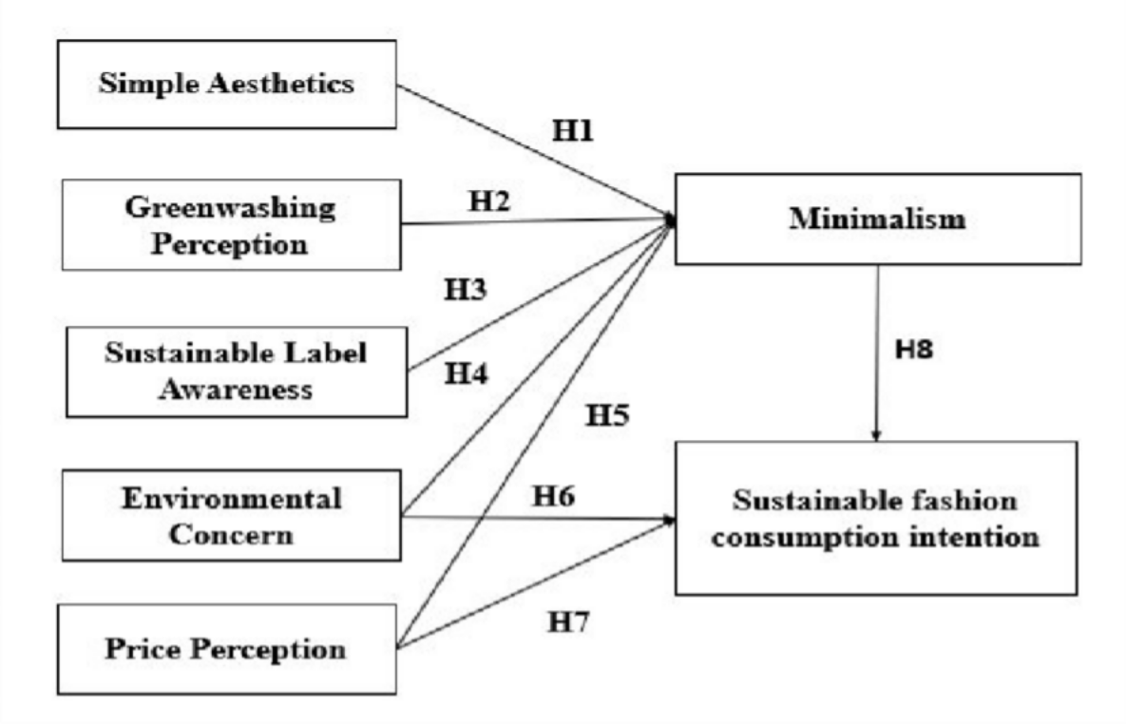

Figure 2. Proposed Research Model
Source: Authors

CHAPTER 3: RESEARCH METHODOLOGY
  - Introduction
.The theoretical foundation outlined in Chapter 2 acts as the groundwork for both formulating and presenting the research methodology in Chapter 3
This chapter covers the following main aspects:
- Research methodology
- Research process
- Measurement scales of the concepts
- Sampling method and data collection

Research Design
    - Research Methodology
This research utilizes a quantitative approach. The team surveyed consumers in Ho Chi Minh City through a questionnaire featuring a 5-point Likert scale (ranging from 1: "Strongly Disagree" to 5: "Strongly Agree"). After data collection, 354 valid responses were selected for further analysis. The analysis commenced immediately after the official survey data was collected, with the research team proceeding through steps to evaluate the proposed hypotheses.
Descriptive statistics were used to provide an overview of the sample, including characteristics such as gender, age, income, and education level.
To assess the reliability of the scales, Cronbach’s Alpha was calculated, applying the standard suggested by Hair et al. (2021), where a value of Alpha ≥ 0.70 is considered sufficient. This ensures the consistency and dependability of the measures
Furthermore, the study employs the Partial Least Squares Structural Equation Modeling (PLS-SEM) method. This is a powerful analytical technique capable of identifying and testing the relationships between variables in the research model, and it is particularly

suitable for models with complex structures. Previously, such relationships were often handled through traditional methods like multiple linear regression, logistic regression, or exploratory factor analysis. However, PLS-SEM has a distinct advantage in minimizing biases that can affect the dependent variable while increasing the R² value, thereby enhancing the model's predictive power (Hair et al., 2017).
The steps for PLS-SEM analysis are as follows:
Preliminary Analysis: The measurement model is evaluated based on a set of criteria recommended by Hair, Howard, and Nitzl (2019) to ensure its suitability before proceeding with more in-depth analyses.
Measurement Model Assessment: The criteria used include: indicator loadings must be greater than 0.7; Cronbach's Alpha should be within the range of 0.60-0.90; and the Average Variance Extracted (AVE) must be at least 0.50 to confirm convergent validity. The AVE index reflects the extent to which the variance of the observed variables is explained by their corresponding latent factor.
Discriminant Validity Assessment: Following the method of Henseler et al. (2015), the heterotrait-monotrait ratio (HTMT) is used to check for discriminant validity between constructs. The recommended HTMT threshold is ≤ 0.90 for constructs that are conceptually similar and ≤ 0.85 for constructs that are conceptually distinct.
Structural Model Assessment: After the measurement model is confirmed, the structural model is examined. First, the Variance Inflation Factor (VIF) is checked to detect multicollinearity, with an ideal VIF value being ≤ 5. Next, the R² and f² indices are calculated to determine the effect size of the independent variables on the dependent variable and to assess whether these variables enhance or diminish the model's predictive power.
Hypothesis Testing: Finally, the bootstrapping method is used to determine the statistical significance of the path coefficients and other parameters in the model. A

hypothesis is accepted if the p-value is less than 0.05 or if the 95% confidence interval does not contain zero.

Research Process
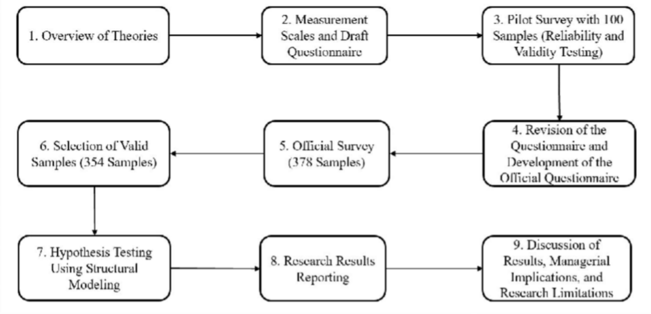

Figure 3. Research Process Design
Source: Authors

Measurement Scales
The author adapted the wording of original scales from earlier research to align with the specific context of the study in Ho Chi Minh City, Vietnam. After considering prior research and the local setting, the author opted for a 5-point Likert scale in the questionnaire. Consequently, respondents' level of agreement is measured on a scale from 1 to 5, where a higher score signifies stronger agreement with the given statement. The 5-point Likert scale is defined as:
1: Strongly Disagree
2: Disagree
3: Neutral
4: Agree
5: Strongly Agree

Measurement Scale for Simple Aesthetic
The measurement scale for the Simple Aesthetic construct was developed based on the original scale by Jain, Joy, and Sharma (2024) combined with the research team’s proposals. The scale comprises four observed variables, denoted from SA1 to SA4.
SA1: I prefer simple, sophisticated designs in a minimalist style.
SA2: I believe that choosing minimalist fashion helps reduce resource waste in the garment industry.
SA3: I buy fewer clothes but focus on quality and timeless aesthetic appeal.
SA4: I believe that pursuing minimalist fashion is a practical way to support sustainability.

Measurement Scale for Greenwashing Perception
The measurement instrument for the Greenwashing Perception construct was created by adapting the original scale developed by Zhang, Li, Cao, and Huang (2018) and incorporating input from the research team. This scale consists of five observed variables, designated GW1 to GW5.
GW1: I notice many fashion products use misleading language about their environmental friendliness.
GW2: I feel that advertising images (e.g., images of nature, plants) are often overused by fashion brands to create a "green" impression of the product.
GW3: I feel that the "sustainable" claims of many fashion brands are often vague and lack specific evidence.
GW4: I believe that fashion brands often exaggerate the actual environmental benefits that their products provide.
GW5: I believe that fashion brands often conceal important information to make their products seem "greener" than they actually are.

Measurement Scale for Sustainable Label Awareness
The measurement scale for the Sustainable Label Awareness construct was developed based on the original scale by Yadav and Kar (2025) combined with the research team’s proposals. The scale comprises three observed variables, denoted from LA1 to LA3.
LA1: I believe I correctly understand the meaning of the "sustainable" label on clothing.
LA2: I recognize labels for clothing made from recycled materials.
LA3: When shopping, I often pay attention to the information on clothing labels.

Measurement Scale for Environmental Concern
The scale for the environmental concern variable was developed based on the original scale by D’Souza, Gilmore, Hartmann, Apaolaza Ibáñez, and Sullivan-Mort (2015) with adaptations by the research team. The scale consists of 3 observed variables, denoted from EC1 to EC3.
EC1: I am concerned about issues related to the environment.
EC2: I am willing to change my consumption habits to contribute to environmental protection.
EC3: Protecting the natural environment helps improve my quality of life.

Measurement Scale for Price Perception
The scale for the price perception variable was developed based on the original scale by Walsh, Shiu, and Hassan (2014) with adaptations by the research team. The scale consists of 4 observed variables, denoted from PP1 to PP4.
PP1: I believe that using sustainable fashion products is an economical choice in the long run.
PP2: I find that sustainable fashion products have a reasonable price.

PP3: I think that sustainable fashion products offer value for the money spent. PP4: I think the price of sustainable fashion is appropriate for the product quality.

Measurement Scale for Minimalism
The scale for the minimalism variable was developed based on the original scale by Iwata (2006) with adaptations by the research team. The scale consists of 4 observed variables, denoted from MN1 to MN4.
MN1: I try to live modestly and avoid buying unnecessary goods.
MN2: When shopping, I carefully consider whether the item is necessary for me. MN3: Even if I have the money, I do not make impulse purchases.
MN4: I try to use up every item I own.

Measurement Scale for Sustainable Fashion Consumption Intention
The scale for the sustainable fashion consumption intention variable was developed based on the original scales by Cho, Ko, and Borenstein (2024) with adaptations by the research team. The scale consists of 5 observed variables, denoted from FI1 to FI5.
FI1: I will share positive things about shopping for sustainable fashion with others. FI2: I am willing to buy sustainable fashion products.
FI3: I will recommend sustainable fashion products to my friends. FI4: I will buy sustainable fashion products for my friends or family. FI5: I am willing to counter criticism about sustainable fashion.

Sample size
The determination of the sample size for this study was crucial to ensure the accuracy and methodological integrity of the analysis conducted with Partial Least Squares Structural Equation Modeling (PLS-SEM). Based on the recommendations of Hair et al. (2021), the minimum required sample size was computed using the formula (minimum

2.486/β)² to achieve a 5% statistical significance level and identify a minimum path coefficient (β) within the 0.11-0.20 range.
For this research, a minimum detectable path coefficient of β = 0.20 was established at a 5% significance level, which resulted in a calculated minimum sample requirement of 155 participants. In practice, data was gathered from 378 individuals. After filtering out 24 incomplete or invalid submissions, the final dataset comprised 354 valid responses. This final sample size not only satisfied the validity criteria for the research but also surpassed the minimum requirement, thus ensuring sufficient statistical power and improving the potential to generalize the study's conclusions.
Adhering to the sample size guidelines from Hair et al. serves a dual purpose: it validates the scientific precision of the research approach and enhances the trustworthiness and dependability of the empirical findings derived from this investigation.

Summary
Chapter 3 of this thesis is dedicated to a detailed presentation of the research methodology, emphasizing the quantitative approach to guarantee that data collection and analysis were performed with scientific rigor. The primary aim of this chapter is to offer a transparent account of the procedures followed to meet the research objectives.
` The study employed a quantitative strategy, carrying out a large-scale survey. Data was gathered using a convenience sampling technique, resulting in 354 valid survey responses from the target consumer demographic in Ho Chi Minh City. The surveys were administered and collected via both online channels (digital platforms) and traditional offline methods. Upon completion of the data collection phase, the entire dataset was compiled and analyzed using SmartPLS 4.0 software. This specialized tool was utilized to test the proposed hypotheses and assess the relationships among the variables. The goal of this analytical process was to generate dependable findings, thereby establishing a

robust basis for the conclusions and recommendations presented in the subsequent chapters.

CHAPTER 4: RESEARCH RESULTS
  - Descriptive statistics
After collecting data through a quantitative questionnaire deployed on the Google Forms platform, the study recorded a total of 378 responses. The data processing involved checking and removing invalid responses, resulting in 354 qualified responses retained for in-depth analysis. The data was coded and processed using the SMART PLS 4.0 software to perform subsequent quantitative analyses, ensuring accuracy and scientific rigor in testing the research hypotheses. Table 4.1 below summarizes the demographic characteristics of the study participants, such as their gender, age, and education level, and average monthly income.

Table 4.1. Descriptive Statistics of Survey Participants

Characteristic | Category | Frequency | Percentage
Gender | Male | 143 | 40,4%
 | Female | 211 | 59,6%
Age | Under 18 years old | 13 | 3,7%
 | From 18 to 27 years old | 187 | 52,8%

 | From 28 to 37 years old | 79 | 22,3%
 | From 38 to 47 years old | 46 | 13,0%
 | Over 47 years old | 29 | 8,2%
Education Level | High School | 25 | 7,1%
 | University/College | 257 | 72,6%
 | Postgraduate | 72 | 20,3%
Income | Less than 5 million VND/month | 29 | 8,2%
 | From 5 to less than 10 million VND/month | 112 | 31,6%
 | From 10 to less than 15 million VND/month | 109 | 30,8%
 | Over 15 million VND/month | 104 | 29,4%
Source: Summary from the authors

Gender
Of the 354 survey participants, males accounted for 40.4% (143 individuals), while females made up a higher proportion at 59.6% (211 individuals). This disparity reflects a greater interest among females in topics related to minimalism and sustainable consumption. This result can be explained by the psychological and consumer behavior characteristics of females, who often prioritize factors such as aesthetics, lifestyle balance, and social responsibility in their purchasing decisions.

Age
The age distribution of the survey sample shows that the 18-27 age group accounted for the highest proportion at 52.8% (187 individuals), followed by the 28-37 age group at 22.3% (79 individuals), the 38-47 age group at 13.0% (46 individuals), the over 47 age group at 8.2% (29 individuals), and the under 18 age group with the lowest proportion at 3.7% (13 individuals). This age structure shows that most participants in the survey are young people, who are considered dynamic, accessible, and highly aware of sustainable living trends.

Education Level
Regarding educational level, 72.6% (257 individuals) of participants had a college or university degree, followed by those with postgraduate education at 20.3% (72 individuals), and 7.1% (25 individuals) of participants who had a high school education. This characteristic indicates that the research sample has a relatively high educational level, contributing to their ability to understand and evaluate complex concepts such as “minimalism” and “sustainable consumption” tthereby improving the trustworthiness of the collected data.

Income
In terms of income, the group earning between 5 and under 10 million VND per month made up the largest proportion at 31.6% (112 individuals), followed by the group with 10 to under 15 million VND/month at 30.8% (109 individuals), the group with over 15 million VND/month at 29.4% (104 individuals), and the group with under 5 million VND/month with the lowest proportion at 8.2% (29 individuals). This income structure reflects tthat the survey sample mainly includes individuals with middle to relatively high income, consistent with the characteristics of urban consumers in Ho Chi Minh City. This group has stable financial capacity and the potential to access products or services associated with sustainable lifestyles.

Measurement Model Evaluation
    - Scale Reliability
After removing unreliable observed variables, it can be seen that all scales achieved Cronbach's alpha values exceeding 0.7, ranging from 0.701 to 0.800. Similarly, all composite reliability values are greater than 0.7. Therefore, these values indicate statistical reliability.
Outer loadings reflect the strength and direction of the association between the observed variables. According to Hair et al. (2021), for an indicator to be considered high quality, its outer loading must be greater than or equal to 0.7 (≥ 0.7). The analysis results indicate that the outer loadings of the indicators GW3, FI5, and MN1 were less than 0.7; therefore, they were removed from the model as they did not meet the standard requirement. The remaining indicators in this study all satisfy the standard requirement.
From the results collected and analyzed in Table 4.2.1, it is shown that all criteria are met, which proves that the observed variables are of high quality, reliable, and appropriate for inclusion in the model.

Table 4.2.1. Results of Cronbach's Alpha, Composite Reliability, Outer Loadings, and Average Variance Extracted (AVE)

Scale |  | Cronbach’s alpha | Composite Reliability  (rho_A) | Composite Reliability  (CR) | Outer Loading | Average Variance Extracted  (AVE)
PP |  | 0.734 | 0.734 | 0.832 |  | 0.554
 | [PP1] |  |  |  | 0.713

 | [PP2] |  |  |  | 0.703
 | [PP3] |  |  |  | 0.788
 | [PP4] |  |  |  | 0.770
GW |  | 0.745 | 0.755 | 0.838 |  | 0.565
 | [GW1] |  |  |  | 0.718
 | [GW2] |  |  |  | 0.745
 | [GW3] |  |  |  | 0.696
 | [GW4] |  |  |  | 0.732
 | [GW5] |  |  |  | 0.703
EC |  | 0.565 | 0.565 | 0.565 |  | 0.665
 | [EC1] |  |  |  | 0.775
 | [EC2] |  |  |  | 0.812
 | [EC3] |  |  |  | 0.857
LA |  | 0.800 | 0.808 | 0.882 |  | 0.714
 | [LA1] |  |  |  | 0.849
 | [LA2] |  |  |  | 0.870

 | [LA3] |  |  |  | 0.814
FI |  | 0.790 | 0.791 | 0.864 |  | 0.613
 | [FI1] |  |  |  | 0.774
 | [FI2] |  |  |  | 0.767
 | [FI3] |  |  |  | 0.750
 | [FI4] |  |  |  | 0.767
 | [FI5] |  |  |  | 0.607
MN |  | 0.701 | 0.703 | 0.833 |  | 0.625
 | [MN1] |  |  |  | 0.699
 | [MN2] |  |  |  | 0.745
 | [MN3] |  |  |  | 0.791
 | [MN4] |  |  |  | 0.745
SA |  | 0.793 | 0.802 | 0.865 |  | 0.615
 | [SA1] |  |  |  | 0.763
 | [SA2] |  |  |  | 0.762
 | [SA3] |  |  |  | 0.829

 | [SA4] |  |  |  | 0.786
Source: Data processed using SmartPLS 4

Assessment of Convergent Validity
According to Hair et al. (2021), convergent validity is assessed through the Average Variance Extracted (AVE), where values of 0.50 or higher are considered acceptable. In this study, the highest AVE value is 0.714 for the construct of Sustainable Label awareness and the lowest AVE value is 0.554 for Price Perception. This suggests that the constructs account for at least 55.4% of the variation in their corresponding indicators.

Discriminant Validity-Heterotrait-Monotrait Ratio (HTMT)
The Fornell and Larcker (1981) criterion for assessing discriminant validity was initially considered for this study. However, according to Henseler, Ringle, & Sarstedt (2015), this method has limitations due to its lack of a solid statistical foundation, which can lead to inaccuracies in evaluating discriminant validity. Therefore, the research team chose to use the Heterotrait-Monotrait Ratio (HTMT) index proposed by Henseler, Ringle, and Sarstedt (2015), which is regarded as a more reliable method.
With the HTMT index, discriminant validity is considered established when the coefficients are below the threshold of 0.85. According to the values shown in Table 4.2.3, it can be seen that all pairs of constructs have HTMT coefficients lower than 0.85. Therefore, the measurement model in this research meets the requirement for discriminant validity.

Table 4.2.3. Heterotrait-Monotrait Ratio (HTMT) of the Scales

 | PP | GW | EC | LA | FI | MN | SA
PP
GW | 0.208
EC | 0.280 | 0.545

LA | 0.393 | 0.573 | 0.539
FI | 0.595 | 0.163 | 0.277 | 0.394
MN | 0.295 | 0.408 | 0.368 | 0.411 | 0.396
SA | 0.239 | 0.523 | 0.833 | 0.661 | 0.142 | 0.493
Source: Data processed using SmartPLS 4

Structural Model Evaluation
    - Multicollinearity Assessment (VIF)
Multicollinearity in a regression model occurs when two or more independent variables have a strong correlation with one another. This high correlation makes it more complex to estimate and interpret the regression coefficients. Before testing the model, the research team conducted a multicollinearity assessment to determine if this phenomenon exists in the structural model. The Variance Inflation Factor (VIF) is commonly used to detect and evaluate the level of multicollinearity as it reflects the strength of the associations among the independent variables in the model.
According to Hair, Howard, and Nitzl (2019), if the VIF value is less than or equal to 3.0, multicollinearity is considered unlikely to be an issue. In Table 4.3.1, all VIF values are below the 3.0 threshold, which indicates that multicollinearity does not occur. Therefore, the proposed model is considered appropriate.

Table 4.3.1. Multicollinearity Statistics: Variance Inflation Factor (VIF) Results

 | PP | GW | EC | LA | FI | MN | SA
PP |  |  |  |  | 1.082 | 1.114
GW |  |  |  |  |  | 1.372
EC |  |  |  |  | 1.112 | 1.805
LA |  |  |  |  |  | 1.618

FI
MN |  |  |  |  | 1.112
SA |  |  |  |  |  | 1.980
Source: Data processed using SmartPLS 4

Coefficient of Determination (R² and Adjusted R²)
The overall structural model was assessed through a bootstrapping technique with 10,000 resamples, which is appropriate when the data are not normally distributed (Streukens & Leroi-Werelds, 2016).
The R² and Adjusted R² coefficients are used to assess the goodness-of-fit and explanatory power of the independent variables in the research model. According to Hair et al. (2021), the value of R² ranges from 0 to 1, where a level of 0.75 represents substantial explanatory power, 0.5 is considered moderate, and 0.25 is weak. In other words, as R² approaches 1, the independent variables can explain a large portion of the variance in the dependent variable; conversely, as this value approaches 0, the explanatory power decreases significantly.
However, when more independent variables are added to the model, the R² value can be inflated, leading to a biased assessment. Therefore, the Adjusted R² coefficient is often used as an alternative because it adjusts for the number of variables in the model, offering a more precise and realistic representation of how the independent variables explain the dependent variable.

Table 4.3.2. R² Test Results

 | R-square | R-square adjusted
FI | 0.261 | 0.255

MN | 0.190 | 0.178
Source: Data processed using SmartPLS 4
The model yielded R² values of 0.190 for MN and 0.261 for FI, respectively. According to Cohen, Cohen, West, and Aiken (2013), these values represent strong explanatory power for both endogenous latent variables within a social science context. The corresponding Adjusted R² values (0.178 and 0.255) also confirm the stability of the model after considering the number of predictors.

Effect Size (f²)
The f² index is used to assess the magnitude of the effect of independent variables on the dependent variable. To perform this evaluation, the study applied the criteria from Cohen, Cohen, West, and Aiken (2013). Specifically, an independent variable with an f² value below 0.02 has almost no effect on the dependent variable; below 0.15 is considered a weak effect; from 0.15 to 0.35 is a medium effect; and above 0.35 is a strong effect.

Table 4.3.3. Effect Size (f²) Results

 | PP | GW | EC | LA | FI | MN | SA
PP |  |  |  |  | 0.205 | 0.019
GW |  |  |  |  |  | 0.020
EC |  |  |  |  | 0.007 | 0.000
LA |  |  |  |  |  | 0.004
FI
MN |  |  |  |  | 0.044
SA |  |  |  |  |  | 0.043
Source: Data processed using SmartPLS 4

The analysis results show that "Price Perception" (PP) has an f² value of 0.205 in its effect on "Sustainable Fashion Consumption Intention" (FI). This represents a medium effect size, reflecting the significant role of the price factor in shaping consumers' sustainable consumption behavior. This result is consistent with the arguments of many previous studies, which suggest that price is both a barrier and an important driver influencing the decision to purchase sustainable products.
The factors GW, EC, LA, and SA have f² values ranging from 0.000 to 0.020, indicating a very small or negligible effect. This suggests that while these factors may be theoretically significant, they have not yet exerted a strong practical influence on sustainable consumption behavior. Notably, "Minimalism" (MN) has an f² value of 0.044 in its effect on "Sustainable Fashion Consumption Intention" (FI). Although this is still a small effect size, it is higher than the other factors (except for PP), indicating a certain complementary role of the minimalist lifestyle in promoting sustainable consumption behavior. This result reflects an emerging trend: consumers are beginning to care about reducing material excess, consuming selectively, and moving towards sustainable values, even though the current level of influence is not yet strong.

Bootstrapping Test and Assessment of Path Relationship Significance
In this study, we applied the Bootstrapping technique with 354 observations from the survey sample, performing 10,000 resamples to test the significance of the relationships after the reliability and validity of the measurement scales were confirmed. The results from the bootstrapping test of the research model are presented in Figure 4 below.

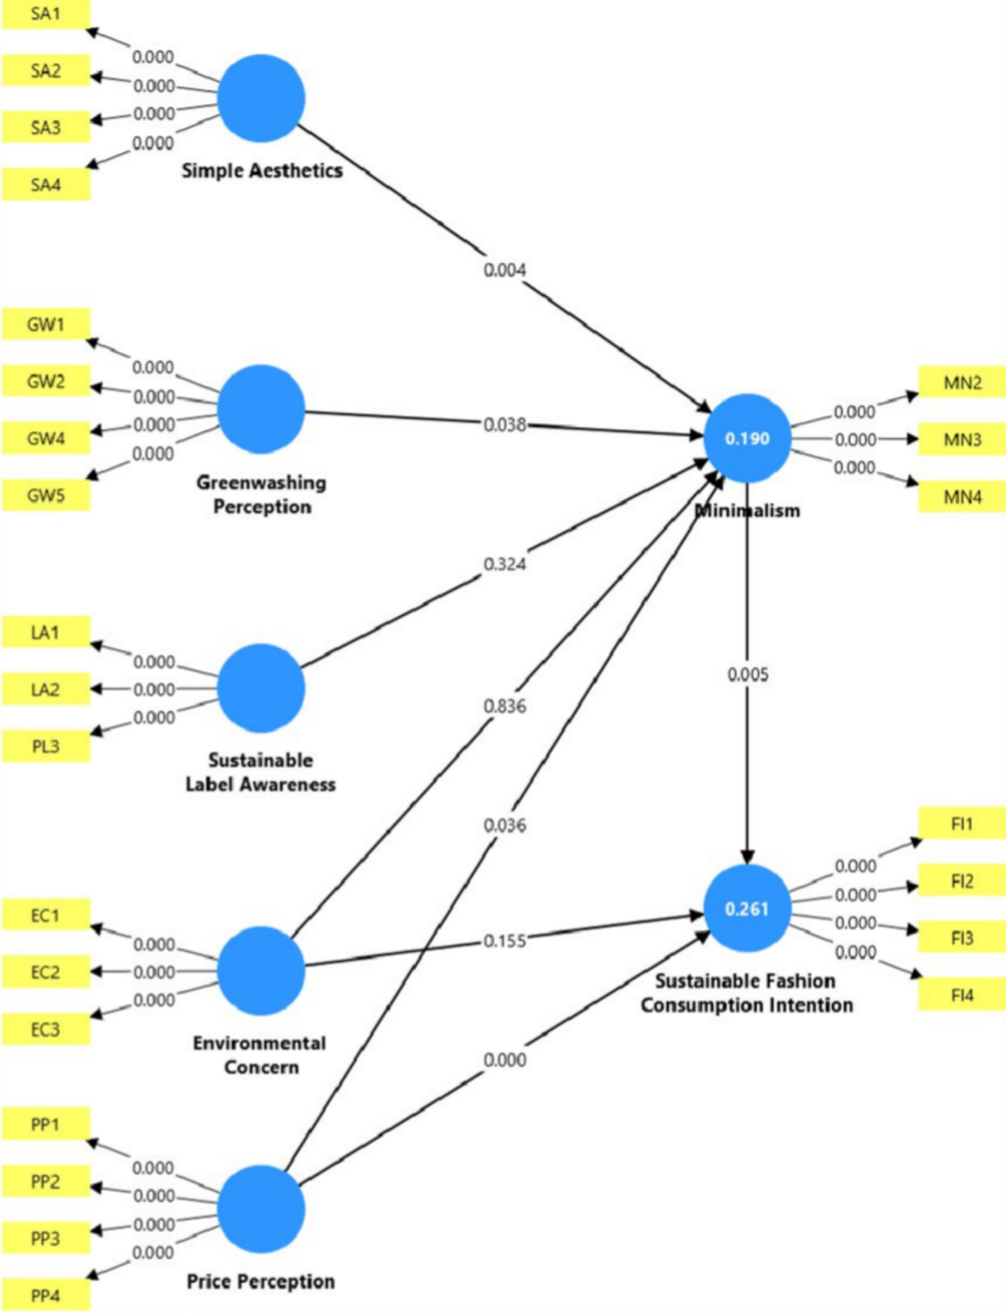

Figure 4. Results of Bootstrapping Test
Source: Data processed using SmartPLS 4

Ten thousand bootstrap samples were used in the bootstrapping technique. As recommended by Hair et al. (2021), a two-tailed test, the Complete Bootstrapping method with Bias-Corrected and Accelerated (BCa) Bootstrap and a significance level of 0.05 were applied for all other parameters. At a 5% significance level, the critical t-value for a two- tailed test is 1.96. The p-value of the path coefficients must be less than 0.05 or not fall within the 95% confidence interval to be considered significant at a 5% error probability (Hair et al., 2021).
The path coefficient results for the proposed relationships are displayed in Table
4.3.4 below, along with their standard errors and p-values.
Hypothesis H1 proposed that simple aesthetics have a positive influence on minimalism. The test results show that simple aesthetics have a positive influence on minimalism (β=0.263, p=0.004 <0.05), thus supporting hypothesis H1.
Hypothesis H2 proposed that the greenwashing perception has a positive influence on the minimalism. After testing, the results demonstrate that the greenwashing perception has a positive influence on the tendency to pursue minimalism (β=0.148, p=0.038 <0.05), thus supporting hypothesis H2.
Hypothesis H5 proposed that price perception has a positive influence on minimalism. After testing, the results indicate that price perception has a positive influence on minimalism (β=0.130, p=0.036 <0.05), thus supporting hypothesis H5.
Hypothesis H7 proposed that price perception has a positive impact on consumers' sustainable fashion consumption intention. The results show that price perception has a positive impact on consumers' sustainable fashion consumption intention (β=0.404, p=0.000 <0.05), thus supporting hypothesis H7.
Hypothesis H8 proposed that minimalism has a positive impact on consumers' sustainable consumption intention. The test results indicate that minimalism has a

positive impact on consumers' sustainable consumption intention (β=0.191, p=0.005
<0.05), thus hypothesis H8 is supported.
Hypothesis H3 proposed that the sustainable label awareness has a positive influence on minimalism. However, after testing, the results show that the sustainable label awareness does not have a positive influence on minimalism (β=0.072, p=0.324 >0.05), thus hypothesis H3 is rejected.
Hypothesis H4 proposed that environmental concern has a positive impact on minimalism. But after testing, the results show that environmental concern does not have a significant impact on minimalism (β=-0.016, p=0.836 >0.05), thus hypothesis H4 is rejected.
Hypothesis H6 proposed that environmental concern has a positive impact on consumers' sustainable fashion consumption intention. However, after testing, the results show that environmental concern does not have a positive impact on consumers' sustainable consumption intention (β=0.077, p=0.155 >0.05), thus hypothesis H6 is rejected.

Table 4.3.4. Results of Research Hypothesis Testing in the Model

 | Original sample (O) | Sample mean (M) | Standard Deviation (STDEV) | T statistics (|O/STDEV| | P-value
SA→ MN | 0.263 | 0.262 | 0.090 | 2.917 | 0.004
GW→MN | 0.148 | 0.154 | 0.072 | 2.071 | 0.038
LA→MN | 0.072 | 0.069 | 0.073 | 0.986 | 0.324
EC→ MN | -0.016 | -0.009 | 0.077 | 0.206 | 0.836

PP → MN | 0.130 | 0.132 | 0.062 | 2.099 | 0.036
EC→ FI | 0.077 | 0.077 | 0.054 | 1.422 | 0.155
PP → FI | 0.404 | 0.406 | 0.055 | 7.362 | 0.000
MN→FI | 0.191 | 0.187 | 0.067 | 2.840 | 0.005
Source: Data processed using SmartPLS 4
The analysis results indicate that the square root of the AVE value for each construct is higher than the correlation coefficients with other latent variables, demonstrating that the constructs have achieved discriminant validity and ensuring their independence and clarity within the research model.

Table 4.3.5. Summary of Hypothesis Testing Results

 | Results
 | Sig | Conclude
H1: Simple aesthetics has a positive influence on minimalism. | 0.004 | Supported
H2: Greenwashing perception has a positive influence on the tendency to pursue minimalism. | 0.038 | Supported
H3: Sustainable label awareness has a positive influence on minimalism. | 0.324 | Rejected
H4: Environmental concern has a positive impact on minimalism. | 0.836 | Rejected

H5: Price perception has a positive influence on minimalism. | 0.036 | Supported
H6: Environmental concern has a positive impact on consumers' sustainable fashion consumption intention. | 0.155 | Rejected
H7: Price perception has a positive influence on sustainable fashion consumption intention. | 0.000 | Supported
H8: Minimalism has a positive impact on consumers' sustainable fashion consumption intention. | 0.005 | Supported
Source: Data processed using SmartPLS 4

Mediation Analysis
The mediating role of variables in the relationships with the dependent variables was assessed using the Bootstrap 10000 method (Hair & Alamer, 2022). The results indicate that MN serves as a significant mediator in the relationship between SA and FI. However, MN does not function as a significant mediator in the relationships between EC and FI, PL and FI, PP and FI, and GW and FI.

Table 4.4. Results of hypothesis testing in the model

 | Original sample (O) | P-value | Result
EC → MN → FI | -0.003 | 0.842 | Rejected
LA → MN → FI | 0.014 | 0.411 | Rejected
SA → MN → FI | 0.050 | 0.008 | Supported

